BIOC 455
Lecture # 31 – Serotonin 1
Lecturer: Dr. Leyton – Wednesday, March 28, 2007

NOTE: This NTC is meant to be used as a study aid to supplement your own class notes. Hence, not all of the text or diagrams contained in the lecture slides will be reproduced here.

Please send any comments or questions about NTCs to either Wanda or James through e-mail at u3.represent@gmail.com .

Slide 1- A brief history of Serotonin
There was a substance in the blood that was known to be released by platelets in response to blood clots and to cause constriction of vascular smooth muscle. In the 1930s, this substance was isolated in the gut and was named enteramine. Soon after, this same substance was found in the blood, and after successful synthesis in the lab, this substance was re-named Serotonin (5-HT).
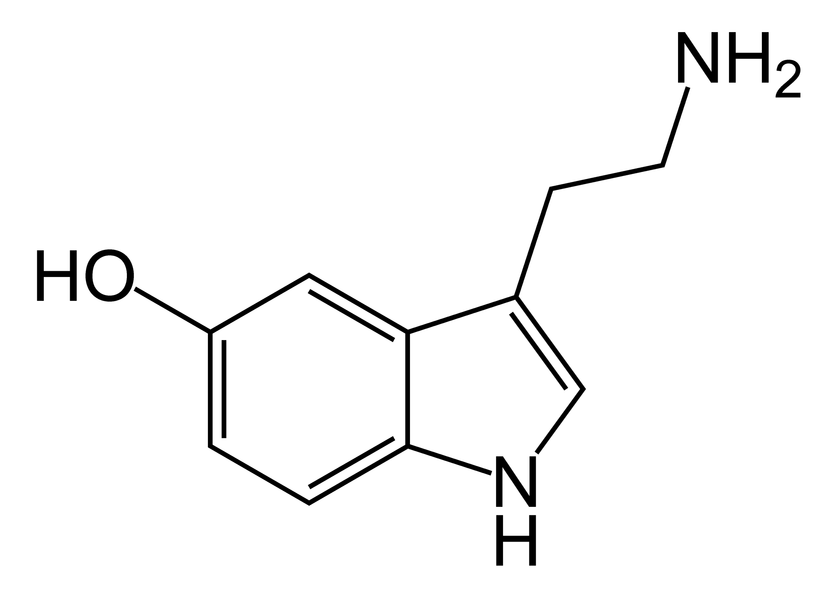
The structure is very similar to LSD and Mescaline. LSD inhibits serotonin’s ability to induce muscle contractions.

Slide 2- The Serotonin System
-Serotonin does not cross the BBB (because it is hydrophilic), therefore its discovery in the brain indicates that it must be synthesized there. Serotonin cell bodies are found along the upper middle brainstem, and the cells project throughout the brain. The dorsal raphé is made up f the B7 cell body (largest) and the more caudal B6 cell body, and it innervates the striatum. The median raphé innervates the hippocampus, the septum, and the hypothalamus. The raphé nucleus receives input from other cell body groups in the brainstem.
-Serotonin neurons contribute to behaviors and physiological functions such as mood, appetite, sexual behavior, impulse-control, aggressive behavior etc.
-There is an average of 10mg of 5-HT in an adult human.

Slide 3- Rat Serotonin Neuroanatomy
-There are 9 main groups of serotonin cell bodies in the rat brain labeled B1-B9. They are all located in the upper brainstem/ midbrain region and project to all major areas of the brain.

Slide 4- Dorsal vs. Median Raphé
-There are two types of 5-HT fibers:
1. Type M: From the Median raphé, have thick Myelinated axon tacks, have large, round synaptic boutons on terminal branches (short, thin branches).
2. Type D: From the Dorsal raphé, have profuse branching, thin axon tracts with small boutons/ varicosities along the axonal tracts
-Fenluramine (a 5-HT releaser/ re-uptake inhibitor) preferentially acts on the dorsal raphé system; whereas, MDMA does the same thing but in both the dorsal and median raphés. The type D cells however, are more susceptible to the neurotoxic effects of MDMA.

Slide 5- Serotonin Synthesis
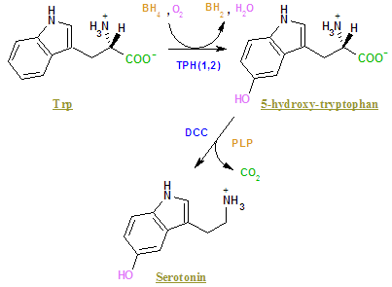
-The rate limiting step in the synthesis of serotonin is the first step where tryptophan hydroxylase (TPH) hydroxylates tryptophan, producing 5-Hydroxy-tryptophan (5-HTP). In the next step, Aromatic Amino Acid decarboxylase (AAAD) removes the carboxylic acid group, producing Serotonin of 5-Hydroxytryptamine (5-HT). This second step occurs very quickly, which is why 5-HTP is found in only trace amounts in the brain. If one adds 5-HTP, one can increase serotonin synthesis; however, since AAAD is found in other parts of the brain, serotonin will be produced in non-serotonin neurons.

Slides 6 to 12- Serotonin Synthesis Cont.
-TPH is approximately 50-75% saturated; therefore, adding more tryptophan can increase serotonin synthesis. The study on slides 6 and 7 shows that tryptophan can get into the brain and brain tissue and increases 5-HT synthesis, proving that 5-HT synthesis is normally occurring at a lower than maximal rate in humans. One can also decrease serotonin synthesis by decreasing tryptophan availability.
-There are two other substrates for TPH that are involved in serotonin synthesis:
1. Oxygen: Normally, TPH is totally saturated with oxygen. In the study on slide 9, researchers inhibited AAAD function, and measured the rate of build-up of 5-HTPm (5-HTP is not converted into 5-HT). It shows that plasma O2 levels correlate with 5-HTP accumulation. In other words, the more oxygen available in the plasma, the more TPH will convert Tryptophan to 5-HTP, and therefore, serotonin synthesis will increase.
2. BH4: This is an essential co-factor for TPH, and is also an essential co-factor for tyrosine hydroxylase, phenylalanine hydroxylase, and nitric-oxide synthase. Therefore, BH4 knockout mice cannot synthesize monoamines. There are two inherited disorders associated with a genetic defect in BH4-synthesizing enzymes:
-Atypical Hyperphenylalaninemia: autosomal recessive, symptoms include convulsions, drowsiness, and disturbances of muscle tone.
-Doparesponsive Dystonia (Segawa’s disease): characterized by childhood-onset dystonia with remarkable responsiveness to low doses of L-DOPA.
-Serotonin synthesis occurs in both the cell body, and the terminals.

Slide 13- Serotonin Transporters
-After it is synthesized, serotonin is stored in vesicles, which then fuse to the cell membrane and release the serotonin by exocytosis. Once in the synaptic cleft, serotonin can bind to receptors either pre-synaptically or post-synaptically. The serotonin is taken back into the cell by serotonin stransporters (SERT). These transporters affect how much serotonin remains in the synaptic cleft and reaches the post-synaptic terminal. Selective serotonin re-uptake drugs have been used to treat depression by blocking these transporters.

Slides 14 and 15- Serotonin Metabolism
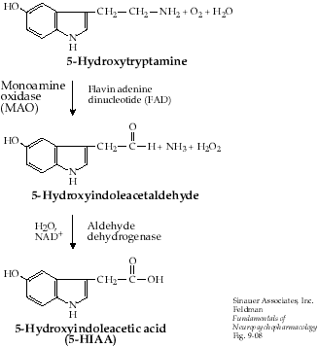
-Serotonin breakdown is a two-step process: First, Monoamine Oxidase (MAOA) catabolizes 5-HT into 5-hydroxyindoleacetaldehyde. This is then oxidized by aldehyde dehydrogenase to give 5-hydroxyindoleacetic acid. This is the main serotonin metabolite in the brain. In the pineal gland, however, serotonin is converted first into N-Acetyl serotonin by 5-HT N-acetyl transferase, and then that is converted into Melatonin by 5-hydroxyindole-O-methyltransferase (see slide 15 for structures). Melatonin affects our circadian rhythms and sleep-wake cycles; therefore, some people take melatonin supplements in order to reduce “Jetlag.”

Slide 16- Serotonin Receptors
-Researchers believe there to be about 14 serotonin receptor subtypes (note: we do not need to memorize all of the different subtypes, basically just 5-HT1A and 5-HT2A). The different subtypes differ in their effects on the post-synaptic neurons. For instance, some may inhibit or stimulate adenylyl cyclase. The 5-HT1A receptor is particularly interesting because it is located both pre and post synaptically (primarily in limbic regions). This shows that they may regulate neurotransmission in areas related to mood and motivational states. The 5-HT2A receptors are concentrated in the frontal cortex.

Slides 17 and 18- 5-HT2A Receptor Internalization
-100 nM or more of serotonin induces receptor internalization. What happens is the receptor is carried away from the cell surface membrane and into the intra-cellular space. This begins very quickly (~2 min) and by 10 minutes, most of the receptors are internalized. By labeling the C-terminus of 5-HT2A receptors and inhibiting protein synthesis with cyclohexamide (to ensure that the receptors viewed are actually the receptors of interest), researchers were able to determine that the receptors return to the cell surface in 2.5 hours.

Slides 19 and 20- Positron Emission Tomography
-The process involves coincidence detection of Gamma rays. First, PET tracers release of positron and this positron travels 0.2 to 7 mm and collides with an electron. This is known as annihilation. This annihilation produces gamma rays. The gamma rays travel at approximately the speed of light in opposite directions and hit two opposite detection crystals simultaneously. These detection crystals then emit light, which is amplified, converted to an electric signal, and coincidence detection can determine how much tracer is where in the brain. 18-F has the least energy, and travels the least distance before colliding with an electron, and therefore provides the greatest resolution. PET can be used to visualize serotonin synthesis and other processes in the serotonin system.

